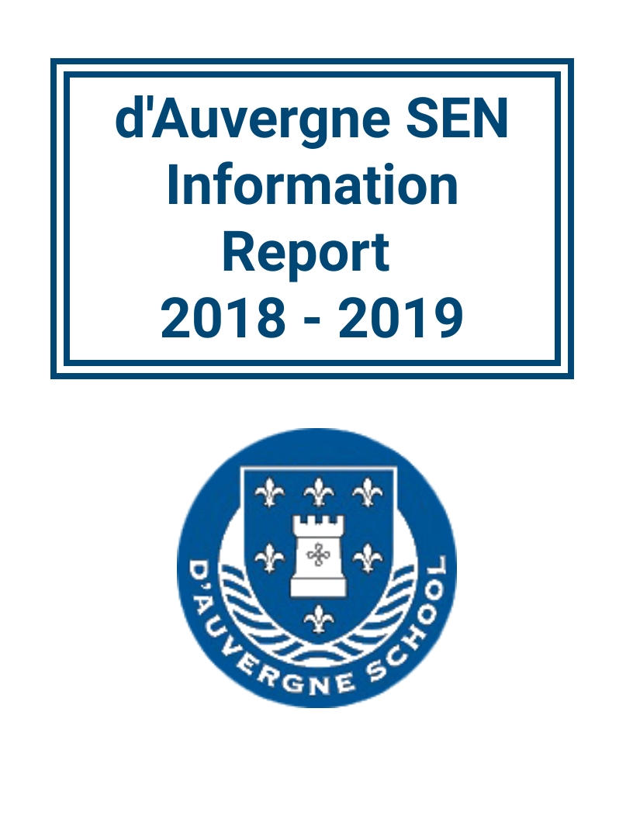

2021 - 2022

Identification of Need Overview
 | EYFS |  |  |  | Key Stage 1 |  |  |  | Key Stage 2
Category of need | Nursery |  | FS |  | Year 1 |  | Year  2 |  | Year  3 |  | Year  4 |  | Year  5 |  | Year  6 |  | Totals
 | M | F | M | F | M | F | M | F | M | F | M | F | M | F | M | F
Cognition & Learning
Specific Learning Difficulty: |  |  |  |  |  |  |  | 1 | 1 |  | 2 | 2 |  | 1 | 2 | 3 | 12
Mild/Moderate Learning: |  |  |  |  |  |  | 2 |  | 2 |  | 1 | 3 | 1 |  | 1 |  | 10
Social, Emotional and Mental Health: |  |  | 2 |  |  | 2 | 1 |  | 3 |  | 1 | 2 | 7 | 1 | 1 |  | 20
Communication & Interaction
Speech, Language & Communication: |  | 1 | 6 | 6 | 1 |  |  | 1 | 1 |  |  | 2 | 1 |  | 1 |  | 20
Autistic Spectrum Condition: | 1 |  | 1 |  | 1 |  | 1 |  |  |  | 1 |  | 2 | 1 |  |  | 8
Physical/Sensory Impairment
Visual Impairment: |  |  |  |  |  |  |  |  | 1 |  |  |  |  |  |  |  | 1
Hearing Impairment: |  |  |  |  |  |  |  |  |  |  |  |  |  |  |  |  | 0
Multi-Sensory Impairment: | 1 |  |  |  |  |  |  |  |  |  |  |  |  |  |  |  | 1
Physical: |  |  |  |  |  |  |  |  |  |  | 1 |  |  |  |  |  | 1
Totals: By year group and gender | 2 | 1 | 9 | 6 | 2 | 2 | 4 | 2 | 8 | 0 | 6 | 9 | 11 | 3 | 5 | 3 | 64% Boys
Pupils supported through SEN Support |  |  |  |  |  |  |  |  |  |  |  |  |  |  |  |  | 73

SEN by Primary and Secondary Need:
Need | Student Totals
Speech, Language and Communication | 32
Social, Emotional, Mental Health | 26
Specific Learning Difficulty | 11
Moderate Learning Difficulty | 18
Autism Spectrum Disorder | 13
Physical Disability/Medical Condition | 2
Visual Impairment | 1
Profound and Multiple Learning Difficulty | 1
Hearing Impairment | 0

Outside Agency Support:
Areas of Need | Number of Children
Speech and Language Therapy | 27
Visual Impairment Team | 3
Educational Psychologist | 12
CAMHS | 7
Primary Mental Health Worker | 2 (consultancy only)
ASCIT | 3
SEMHIT | Consultancy
Occupational Therapist | 1
Wellbeing | 4

School Interventions:
Lego Club
Precision Teaching
Speech and Language/WELLCOMM
Reading
ELSA/Wellbeing/Social Emotional
Maths - First Class @ Number
Read Write Inc.
Nurture Group/Forest School
Nessy
Jersey Tutoring Programme

SEN Data Summary
The majority of our SEN children are achieving below or well below ARE in reading, writing and maths.
When compared to progress within age related expectation, progress of our SEN children may be considered slow with 15% of our SEN pupils progressing from ‘below’ to ‘at’ between Autumn and Summer 2021, with an average of 18% of our SEN pupils reaching age related expectation in reading, writing and maths. However, when progress is measured from their starting point, the large majority of our SEN pupils made good or very good progress in reading, writing and maths.
Progress of individuals with Special Educational Needs is recorded on Pupil Provision Maps, where pupils are assessed against their starting points as opposed to the attainment of their peers.
Provision is made for pupils who do not access a full schedule of ‘Programmes of Study’ education, this is regularly reviewed, with a focus on progress.
Strengths:
18% of our SEN children are achieving ARE or above in reading, writing and maths.
The majority of our SEN pupils are making good academic and engagement progress from their starting points.
Areas for Improvement:
On average, half of our SEN pupils are achieving well below ARE.

Information on who has responsibility for SEN
Responsibility for SEN within the school:
SENCO - Josie Fernandes:
-Supporting the identification of children with special educational needs.
-Co-ordinating provision for children with SEN.
-Liaising with parents
-Liaising with outside agencies and professionals
-Ensuring that the school keeps the records of all pupils with SEN up to date.

Class Teachers:
-To provide high quality class teaching
-To provide an adapted and personalised curriculum for SEN pupils
-To plan, monitor, review and implement provision for SEN pupils
-To keep parents informed

SLT:
- To ensure that SEN support meets pupils’ needs and is cost-effective.
- Working collaboratively with the SENCO to ensure high quality practice
- Supporting teachers and support staff
- Monitoring teachers and support staff

Identifying and Assessing

Consulting Parents/Carers
- Parents meet with Teacher/SENCO/Keyworkers/Head Teacher when necessary
- Parents are consulted on interventions/provisions and thoughts are recorded on provision maps
- Three Reports from class teacher are sent home, each year, identifying area of special need
- Parents have three consultation meetings a year with class teacher (and SENCO where requested)
- Assessment results from in school assessments are put into a comprehensive report and shared with parents
- Parents are invited to meetings with other professionals and SENCOs, following and/or during involvement
- Emails between Teacher/SENCO/Head Teacher and Parents – these are saved on the pupil’s file
- Annual Reviews
- Evidence towards Record of Need Targets, shared with parents
- Parent survey

Consulting Children with SEN

- Children with a Record of Need have a fortnightly meeting with their teacher to review progress towards targets and set new targets
- Children are consulted on interventions/provisions and thoughts are recorded on provision maps
- Children provide feedback on their report (supported where needed)
- As much as possible and where appropriate, children attend meetings being held about their learning and needs
- We are using and developing creative systems to record ‘pupil voice’

Assessing and Reviewing

In addition to our standard school data collection:
- Provision Maps are continually updated with exit data and are a ‘live’ reflection of what provision is in place for a child at any time
- SEN Meetings with Class Teachers were held termly
- Pupil Progress Meetings were held
- Termly meetings with Class Teachers of pupils with a Record of Need and SENCo to monitor progress
- SIMS and SIMS Discover were used to record and monitor SEN progress
- Children with a Record of Need have a fortnightly meeting with their teacher to review targets and discuss next steps Children accessing P-Scales have a monitoring sheet in the front of their books, this is used by all supporting adults to monitor progress and gather evidence.
Transition
- d’Auvergne works closely with external agencies and advice from these is sought and followed
- Class Teachers and other appropriate school staff receive recent and historic SEN information about their pupils
- Additional visits to Secondary Schools
- Comprehensive transition plans are made, for children with additional needs, when they transfer into a different phase of their education
- Meetings with new teachers and other appropriate staff, keyworkers, pupils and parents
- When appropriate graduated transfer took place to ensure smooth transition
- Time was allocated to teachers to prepare for transition between year groups

Teaching children and young people with SEN
Our main approach for supporting children with SEN is high quality teaching.
We believe that every teacher is a teacher of SEN; SENCo and SLT support all teachers in achieving optimum success with our pupils with SEN.
d’Auvergne School is an inclusive school and during 2018-2019 all pupils received whole class differentiated teaching and a balanced and broad curriculum, including outdoor learning and trips and visits. We fully supported all our pupils (including those with SEN) to access all learning opportunities and make additional provision where necessary (eg. by providing additional adult support).
Adaptations to the Curriculum and Learning Environment
- Class Teachers differentiate lessons to meet all learners’ needs.
- Teachers considered pupils’ levels of attainment and, where indicated, selected targets that were not within ARE for specific pupils with SEN.
- The SENCo deployed additional support staff and Keyworkers to meet the needs of pupils with SEN.
- Where sought, professional advice was followed, and interventions put in place to meet needs of pupils with SEN.

Expertise and Training of Staff
- d’Auvergne staff have ongoing training and support from other professionals
- TAs received bi-weekly in-school SEN focussed training
- We regularly hold in-school training.
- The SENCo held a range of staff meetings throughout the year
- SENCo attended all relevant SENCo training
- SENCO has a Level 3 qualification and is an ELKLAN Level 1 tutor
- All KS1 and KS2 TAs are ELKLAN L1 trained.
- All KS1 and KS2 Tas have received MITA training

Evaluating the Effectiveness of Provision
- Book Looks
- Observations of teachers and TAs
- Monitoring of the effectiveness of provisions/interventions – provision maps, intervention monitoring sheets, precision teaching
- SEN Assessments
- Fortnightly teacher and child Record of Need meetings
- Review meetings with parents, teacher and SENCo
- Weekly supervision meetings with Headteacher, SENCO, EAL, JP and Wellbeing Lead

How Children Were Enabled to Engage in Activities Available to All
- We are an inclusive school, and all children are able to access all opportunities.
- SEN children are not excluded from any opportunities on offer.
- Teachers strive to find out children’s interests and tailor the provision in school to meet these.
- Where necessary parents were invited to support children with SEN on trips and additional adults were provided.
- Risk Assessments were completed for every trip and off-site school activity. These made provision for all pupils, including those with SEN.
To best support identified priority needs, we are:
- Providing support assistants with fortnightly training with the school SENCO and outside agencies. All KS1 and KS2 support assistants are working towards an ELKLAN L1 Speech and Language qualification.
- Holding regular meetings between teachers and SENCO to review the needs, support, and progress of Special Educational Needs pupils – actions are then set accordingly.
- Holding fortnightly reviews of RON targets, by pupil and teacher or support assistant. Our records show that children receiving Banded Funding are making good progress towards their targets.
- Class teachers and keyworkers supporting children with a Record of Need or who are receiving a higher level of keyworker support meet on a weekly basis to share targets, planning and discuss expected outcomes for the child.
- Children with a Record of Need have their RoN targets reviewed on a bi-weekly basis
- Providing language and nurture focussed groups to our identified KS2 pupils.
- Teachers are provided with the opportunity to attend Webinar sessions, delivered by NASEN – these are assigned by the SENCO according to the needs of the pupils in the class.
Our October 2019 Parent Survey showed that 100% of parents either agreed or strongly agreed that we provide the support their child needs to succeed.

Other Services
(including health and social care, and voluntary sector organisations)
In April 2019 d’Auvergne employed a fulltime Safeguarding and Pastoral Lead
d’Auvergne’s School SENCo and Pastoral Lead co-ordinated appropriate intervention both from within school resources and from external agencies from initial identification of learning needs
The SENCo and Pastoral Lead were responsible for making the decision to involve other services after obtaining parental consent. Where referrals were made, these were discussed on a case-by-case basis directly with the agency involved, parents, class teacher and also at termly PARM meetings.
Improving Emotional and Social Development
Emotional and social development of all pupils is a key priority at d’Auvergne. We have a wide variety of resources available to support our pupils’ wellbeing:
- A fulltime Pastoral Lead
- A Wellbeing Room
- Wellbeing Support from Louise Mollet, our Wellbeing Facilitator (1 day per week) both one to one and whole class sessions
- PSHE curriculum
- Health and Intimate Care Plans
- We have 3 trained ELSAs, one working full-time
- Whole School assemblies
- Social Skills
- Clear positive expectations in school
- Piloted a wellbeing scheme, ‘A Friend in Me’
- Nurture Group
- Outdoor learning and a fulltime outdoor learning lead

Parental Complaints
d’Auvergne School has a Complaints Policy and Procedure which applies for all children and parents. We encourage parents to share concerns with class teachers, SENCo of other members of SLT. All members of SLT and the SENCo have their contact details available on the school website.
Accessibility Plan
- Soundfields were installed in the new part of the school building (opened September 2016).
- Wheelchair access is available to all areas of the school and facilitated to the first floor by a lift.
- Refuge points for wheelchair users at top of staircase.
- There are disabled toilets on each floor, and in each wing of the building.
- A changing table was bought (to be used with a pupil in Nursery).
- TEACCH Workstations were operational in 3 classrooms.
Initiatives to Improve Quality of SEN Provision
- We streamlined our interventions to those we are trained in and have a proven track record
- We provide additional 1:1 reading support before school to avoid disruption to class time
- We changed our provision maps and how we use them
- We engage with parents about all provision and outcomes of assessments and give ways to support at home
- Following assessments SENCo. provides teachers and parents with a comprehensive report complete with suggestions for how to support
- We held SEN staff meetings and ‘Lunch and Learns’
- SENCo trained to become an ELKLAN L1 Tutor and began training TAs in L1 ELKLAN
- We worked with speech and language to screen all children in foundation stage with WellComm and ran language circles based on the screening results
- SENCo worked collaboratively with SLT, staff and parents to write an SEN policy
- TAs received fortnightly SEN focussed training from the SENCO and other professionals
- We brought in new assessments and interventions, including SENT Maths Assessment and Toe by Toe, a dyslexia intervention
Additional Support for Parents (including services and organisations)
With support from the Early Help process and our family support worker we were able to direct parents to a range of support services including parenting services at the bridge, school nurse, and The Jersey Online Directory. We hold the Triple P program at school that a number of parents accessed.
We also have a parenting section on our website where parents can find out about additional support services.

