d’Auvergne Primary School
First Aid Policy

Review Date: Summer 2018
Review Schedule: Annual
Person(s) Responsible: Head teacher/Lead First Aid Practitioner
AIMS:
The aim of this policy is to set out guidelines for all staff in school in the administering of First Aid to children, employees and visitors.
Teachers and other staff in charge of children are expected to use their best endeavours at all times, particularly in emergencies, to secure the welfare of the children at the school in the same way that parents might be expected to act towards their children. In general, the consequences of taking no action are likely to be more serious than those of trying to assist in an emergency.
SHARING OF INFORMATION
This policy and policies it references shall be shared with all employees during their induction. Posters displaying the names of employees with first aid qualifications will be clearly displayed around the school. These are updated training has been undertaken.
QUALIFIED FIRST AIDERS
A person is suitable qualified if they have undertaken St. Johns Ambulance or other approved provider training. At d’Auvergne, the trained first aiders are:
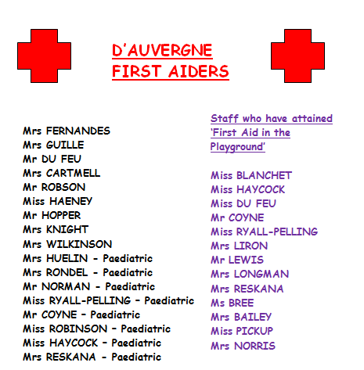

APPLICATION

A qualified First Aider must be consulted immediately in the event that a child (or member of staff) should sustain a major injury or injury of the following nature:

• Any respiratory difficulties
• Cut to head or serious bang to the head
• Suspect sprain or break
• Burns
• Stings: i.e. bees/wasps/insects (due to the possibility of allergic reaction)

In addition, a qualified First Aider should be consulted to treat pupils who are known to have a specific illness i.e. diabetics/pupils known to have allergic reactions/pupils with Epipens in school - irrespective of the type of illness or injury sustained. All staff are trained annually in the administration of Epipens and asthma inhalers. In the event of a major injury, a First Aider must be notified first and an ambulance called immediately afterwards. Children with specific needs have a personal care plan to ensure their safety. This should always be consulted.

There is an additional policy in place for - Administering Medicines
PROCEDURES
The member of staff responsible for the child should either carry our First Aid, if qualified, or take the child to a First Aider. An informed assessment will be carried out and the appropriate treatment given. If a child needs to be sent home or to a doctor or hospital owing to injury in school this must be authorised by the Headteacher or, in her absence, by a member of the leadership team. Parents are to be informed as soon as possible.
In the event of minor injury, once treated, the class teacher must be informed so that they can liaise with Parents/Guardians/Out-of-school club/Carer at the end of the school day. Should the child be feeling unwell or have been sick in school, the class teacher must be notified so that an informed decision may be made.
Should the decision be that parents be notified/the child needs to go home, the office should be contacted to confirm authorisation with the Head/Deputy Head Teacher and parents contacted.
INCIDENT REPORTING
All incidents requiring first-aid (whether minor or major) must be recorded in the school First-Aid book. This is situated in the store room off the staff room. (APP 2)
All incidents that require hospital treatment must be recording on a Notifiable Accident report. This should be completed by the adult involved and a member of the leadership team. This on-line recording form can be found on the desktop of all admin users (Admin staff, Head Teacher and Deputy Head teacher)
All accident/ injury and first aid records will be monitored by the headteacher/deputy headteacher to help identify trends as part of the school’s risk assessment process. This is also monitored by the Health and Safety committee.
ACCIDENTS INVOLVING A CHILD’S HEAD
The school recognise that accidents involving the pupil’s head can be problematic because the injury may not be evident and the effects only become noticeable after a period of time.
• Where emergency treatment is not required, a ‘Head bump’ letter will be sent home to the child’s parents or guardians.
• Head bump forms are kept in the accident book in the First Aid cupboard in the staff room. (APP 1)
FIRST AID MATERIALS, EQUIPMENT AND FACILITIES
All staff must acquaint themselves with the position of the First Aid kits. These are kept:
• in the first aid cupboard in each classroom – this is marked with a green cross
- first aid room
Please report any depletion in stock to the Lead First Aider (Yvonne Huelin) who is responsible for replenishing the boxes and for conducting a check of contents.
First Aid Boxes or a First Aid Belt must be taken out onto the playground during break- times and returned to the classrooms afterwards.
First Aid kits must be taken on all school trips by the nominated First Aider for the group.
The administering of items such as antiseptic creams etc are not permitted in case of allergic reaction. Cuts and grazes should be treated with gauze and clean water and Elastoplast plasters / micro pore applied where applicable. There are sick bags in the rest room for pupils who feel sick. The caretaker should be notified is clearing/cleaning of an area is necessary.
PROTECTION AIDS
Disposable gloves must be worn when dealing with all injuries which involve the loss of blood. Sterile wipes and mouth guards should be used for any mouth to mouth situations. The appropriate disposal of cleaning and treatment resources is to be ensured at all times.
CLASS MEDICAL LIST:
Each class profile must contain an up to date class medical list, a list of pupils with specific dietary requirements and other medical conditions such as asthma.
It should be made clear whether these pupils have medication in school for their medical needs. The child must be aware that they need to report to their class teacher, Headteacher, lunchtime supervisor or first aider should they be feeling ill. Lunchtime supervisors also need to be informed if a child has a food allergy or requires medication.
PUPILS WITH SPECIFIC DIETRY REQUIREMENTS
Pupils must be fully risk-assessed when food-tasting activities take part at school.
PUPILS WITH SPECIFIC NEED:
It is the responsibility of the SENCO to share information and the responsibility of each member of staff to familiarise themselves with the medical plan for children with specific needs.
Staff will receive additional training where specialized equipment is required such as breathing apparatus.
OFF SITE ACTIVITIES
At least one first aid kit will be taken on all off site activities, along with individual pupil’s medication such as inhalers, epipens etc.
A person who has been trained in first aid will accompany all off site visits.
TRANSPORT TO HOSPITAL OR HOME
The head teacher will determine what is a reasonable and sensible action to take in each case. Where the injury is an emergency and the child is in immediate danger, an ambulance will be called following which the parent will be called.
Where hospital treatment is required but it is not an emergency, then the Head teacher will contact the parents for them to take over responsibility for the child. If the parents cannot be contacted then the headteacher may decide to transport the child to hospital.
Where the head teacher makes arrangements for transporting a child then the following points will be observed:
• transport is safe and provides the appropriate seat restraint for the child
• no individual member of staff should be alone with a child in a vehicle.
d’Auvergne School APP 1
La Pouquelaye, St. Helier, Jersey, JE2 3GF.
Tel: 01534 625858
Email: admin@dauvergne.sch.je
Headteacher: Mrs C Lakeman

Date:…………………………..

Dear Parent or Guardian

Your child ………………………………………………………….. sustained a head injury today at school and has been assessed by a qualified First Aider.
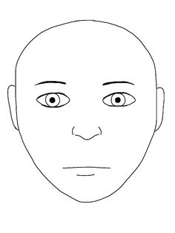
Please see the location of the injury:

He/she has been observed and he/she seems to have developed no further complications or ill effects. Sometimes, however, the onset of concussion can be delayed and if any of the following symptoms occur, your child should be taken to hospital or seen by your doctor immediately.

If your child:
- Feels sick or vomits
- Becomes drowsy
- Complains of an increasing headache
- Starts to bleed from the nose or ears
- Starts to have a fit
- Becomes confused or irritated
- Develops slurred speech
- Develops any unexplained symptoms
It is always better to be cautious when dealing with bumps to the head.
Yours sincerely,
First Aiders Name:……………………………………………………………

Class Teachers Name:……………………………………………………..

APP 2
Date/Time | Name | Incident/Accident | Follow up action | Signed

