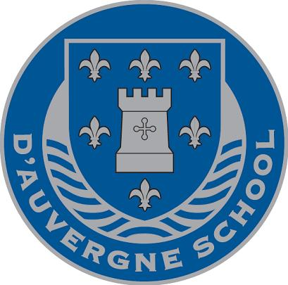

**d’Auvergne After School Club**

Dear Parents/Carers,

We have had a very successful first term of After School Club. We have revised our offerings and added a couple of additional activities. Attached are the activities that are available.

Please complete the Booking Form by writing in the desired activities for each day that you wish to book and return this to school as soon as possible so as not to be disappointed if your activity is fully booked. Bookings will work on a first come first served basis.

Once you have completed and returned the Booking Form we will send you an invoice that will need to be paid in full prior to starting the activities in January.

Tamariki is also still available to parents who wish to continue to use their service instead of, or as well as our activities.

**Practical information**

Please make sure your child is provided with an extra snack and drink for their After School activity. In addition, if they are attending a physically active session, then they will need to wear PE kit and suitable trainers to school on that day.

Activities will start on Monday 6th January and run through to Friday 3rd April 2020.

If you have any questions, then please feel free to discuss this with Rena Nelson, School Business Manager.



Yours sincerely,

Mr. Cooper

Headteacher

**Our Activities for Spring Term 2020**

**Art Club -** The sessions will allow the children to be creative and use different resources to make beautiful pieces of artwork to take home and keep.

**Badminton -** We will be using the Badminton Centre for Year 3 -4. Next term we will look to offer these sessions to a different year group. The children will learn how to use the racquets, game sense and how to hit the shuttlecocks.

**Break Dance -** Scott's (aka Bboy Slo Moshun’s) Hip Hop workshop are a great way to:

* Build self-esteem and confidence
* Get boys and girls dancing
* Develop team work
* Increase and develop stamina, balance, control, patience and determination
* Have a lot of fun

**Chess** - Chess is a universal game, which promotes key intellectual skills such as problem solving, logical thinking, pattern recognition and concentration. Playing chess also fosters intellectual character. It teaches children how to lose and how to win gracefully, to think ahead and foresee the consequences of their actions.

**Cooking** - Basic cooking with recipes will occur within these classes. The children will have a great opportunity to learn new recipes and taste what they have made.

**Drama -** An opportunity to explore creative sides and build confidence through fun activities and acting.

**Football -** These sessions are FREE of charge for children who are invited by Mr Henderson and are either already in the Football teams or training/trialling for one of the school teams. The children will learn the fundamentals of the game, how to work as part of a team and how to compete in a sportsmanship manner.

**Forest School** – This is a two-hour club from 3.00pm – 5.00pm. Children will have the opportunity to use the School’s premises or go on outings to achieve and develop confidence and self-esteem through hands-on learning experiences in a woodland or natural environment with trees.

**Free Play** – This will be based in the MAD room. There will be various toys/play things available to the children throughout these sessions. There will also be a quiet area for children to read or complete homework independently.

**Homework / Reading** – Supported homework and reading opportunities with Mrs Lawrence.

**Karate** – Evolution Kenpo Karate will be joining us on Wednesdays and Fridays. Karate is a great way to gain confidence, get fit and learn how to protect yourself if you ever need to.

**Multi-Sport** – Sports Bug/ Jersey Sport are covering football, tennis, cricket, baseball, hockey, rugby, dodgeball, badminton, athletics, golf and anything else their imaginative coaches can plan a session for. Their emphasis is on making everything as FUN as possible to engage the children.

**Netball** – These sessions are FREE of charge and focused on preparing a Netball squad ready to play against other primary schools in the league. Priority will be given to girls in Years 4, 5 and 6, but boys are also invited to attend.

**Polish Club** – Polish children and parents are invited to meet up in school to do some reading, writing and have a catch up on current events.

**Portuguese Club** – Portuguese children and parents are invited to meet up in school to do some reading, writing and have a catch up on current events.

**STEM Club** – STEM Clubs are a powerful and enjoyable way to engage young people with science, technology, engineering and mathematics (STEM) subjects.

**Ukelele –** Mrs Protherois running a Ukelele club. Ukelele is a member of the guitar family of instruments. It generally has four nylon or gut strings or four courses of strings. Children will get the opportunity to learn this fantastic instrument.

**Zumba** – Zumba Kids classes feature kid-friendly routines based on original Zumba choreography. They break down the steps, add games, activities and cultural exploration elements into the class structure.