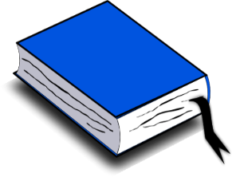
What is a book review?
A book review is a summary of the plot, the characters in the story and how the book made you feel.
Write a book review on your favourite book or a book you’ve recently read.

There are some questions below which you may find helpful to consider when completing your review.

- What happened in the story?

- What was the story about?

- How did the events of the story follow on from each other?

- What was the climax of the story?

- How did it end?

- Who were the main characters? Did they change, if so how?

- Was there anything interesting about the way it was written? Was it written in first or third person?

- Was it a good story? Why?

- What was your favourite moment in the story? Why?

- Would you recommend this book? Who would you recommend it to?

- Did the style of writing remind you of any other authors?

