Q1. Interpreting Line Graphs

Temp

This graph shows the temperature in a room over twelve hours. Answer the questions below.

1a) What was the lowest temperature recorded on the chart.

1b) What was the temperature at 3 o’clock am?

1c) What was the temperature at 11.00?

1d) Which hour shows the biggest rise in temperature?

1e) For how long was the temperature between 16 and 17 degrees?

1f) Can you estimate the temperature at 07.30?

1g) Can you estimate the temperature at 10.00?

Q2. This graph shows the cost of phone calls in the daytime and in the evening.
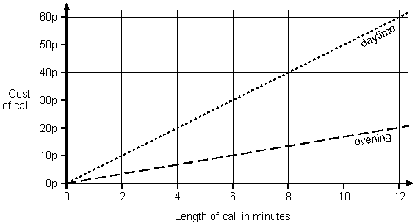

How much does it cost to make a 9 minute call in the daytime?

How much more does it cost to make a 6 minute call in the daytime than in the evening.
Q3. Gavin was ill in March. This is his temperature chart
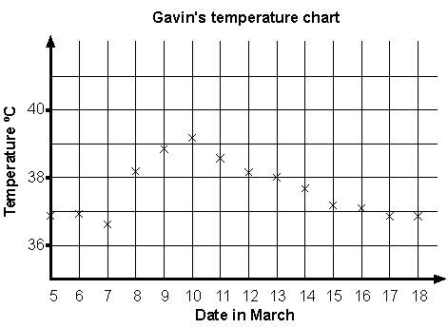

For how many days was his temperature marked as more than 37°C?

Which date showed the largest change in temperature from the day before?

Estimate Gavin’s highest temperature shown on the graph.

Q4. The below line graph shows the lava emissions from Vesuvius.

5a) In which months did the volcano produce over 100 of lava?
5b) What is the range of lava production?
5c) What is the total amount of lava produced in May and November?
5d) When is there the greatest rise in lava production?
5e) In which two months did the volcano produce the samee amount of lava>
5f) What is the total amount of lava produced for the year?
5g) Tell me 3 things about the data that you think no-one else will know.

