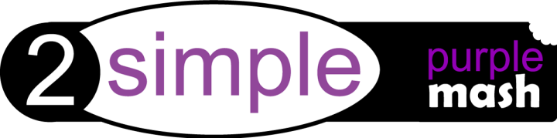
Dear Parent/Carer,

We have recently subscribed to Purple Mash, which is a creative educational website for children. Purple Mash is a cross-curricular resource covering art to science and all subjects in between. Your child can access Purple Mash from home on a laptop, desktop or a tablet.
Purple Mash is a safe environment that does not require any downloading or allow interaction with people online and children cannot make any financial transactions.
We will be encouraging the children to continue their learning at home and Purple Mash is a great resource for this. Your child will be taught how to use Purple Mash in school and will be able to use it without supervision, but you may want to take a few minutes to explore it yourself so that you can help them with their work.
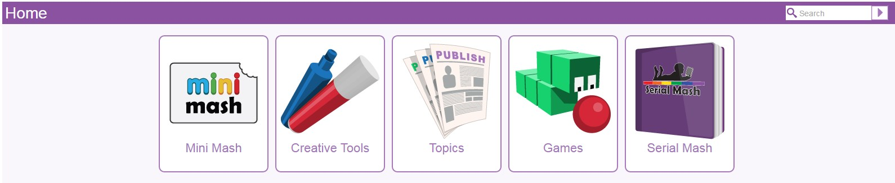

Mini Mash
Mini Mash is the area of Purple Mash specifically designed for children in the ‘Early Years’. Inside, you’ll find a virtual classroom packed full of activities for children aged 5 and under.

Creative Tools
There are 20+ open-ended tools inside Purple Mash. They range in complexity from simple painting programs to sophisticated coding tools.

Topics
Purple Mash has over 1,500 ready-to-use writing and painting projects. They cover everything from aliens to the Victorians. You can use the ‘Topics’ tab to browse by subject or, alternatively, use the search bar at the top right of the screen to look for something specific.

Games
There are a variety of games that are really fun to play but also help children practise their maths & English skills. They are a great way to re-enforce learning outside of school hours.

Serial Mash
Serial Mash is all about getting children to read for pleasure. New books are released over the course of a half-term in the form of a weekly serial. The chapters come with a range of fun and educational activities. Serial Mash is great for solo or guided reading and can be read on tablets.

Saving and Sharing Work
Purple Mash lets your child save their work online. It’s very easy, just look out for the floppy disk icon on the toolbar and follow the simple instructions. To access saved files, go to the ‘Online Work’ tab. Once saved you can also ‘share’ work. Just look out for the globe icon on the toolbar. This will share work to one of our school’s “display boards” or create a link so your work can be viewed online by people that don’t have Purple Mash.

Purple Mash on Tablets
The vast majority of Purple Mash is accessible when using iPads or Android tablets.

Use Purple Mash via your tablet’s browser.

………………………………………………………………………………………………………………………………………………………………………………………….

Purple Mash will be used in school to support your child’s learning. For your child to be able to use Purple Mash we need your permission to set up an account for them using their first name, initial of last name and year they were born.

If you are happy for the school to use this information then please fill in this permission slip and give it back to your child’s class teacher by Tuesday 26th March.

I ……………………………………… give permission for my child ……………………………………………………. in class ……..…………to have an account on Purple Mash.

If you have any questions please don’t hesitate to ask.

Thank you

Miss Leighton

k.leighton@dauvergne.sch.je

