Dear Parents and Carers,

PTA
We’ve had a fabulous day in our fancy-dress costumes – what a lot of fun and what a huge amount of money raised for your PTA! Thank you so much to Charlie (and her family!) and Claire from the PTA for putting together the sweet packets…nearly 600 of them! Great job.

I am delighted to say that our newest trophy has arrived, ready to be presented in December to a very deserving d’Auvergnian (new word!) The ‘d’Auvergne School PTA Community Award’ will be awarded to someone who goes above and beyond in the community (beyond our school). They may be a fundraiser, a carer, a good neighbour…anything really that demonstrates that they are doing something for someone / somewhere else. Parents / Carers – we want to receive your nominations please! If this is your child or someone you know, please let us know.
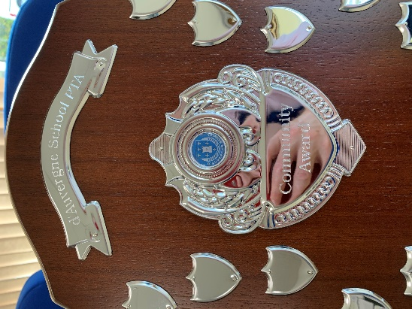
Lunch Boxes
Having sweets very occasionally is a treat, as they obviously aren’t great for our health or dental hygiene. However, what we are seeing a lot of in school at the moment are pre-packed foods at lunchtime. Staff have noticed that this is increasing, and we would suggest that a significant amount of it in a lunchbox on a regular basis isn’t healthy and is expensive. Perhaps, at this half-term break, it’s an opportunity to think about the half-term ahead and how lunch boxes may be made a little healthier? Thanks.

Road Safety
Many of the children are enjoying their bikes and scooters, which is great. However, we are receiving a number of reports of children in the area not using the roads safely or without a helmet. Please can you remind your children of the importance of doing so. With the clocks going back, the afternoons will be darker – quicker so children are more at risk if not keeping themselves and other road users safe. We shall be following this up with the involvement of the Road Safety officer next month.

Shoe Boxes
Thanks for all the community help in putting together Shoe Box gifts for very needy children and families in Romania. Particular thanks to Mrs Nelson, for preparing the 66 boxes! Well done d’Auvergne!

House Winners
Our inaugural House Football competition was held this week (thanks Mr Lim and Mr Henderson). The children had just the best time! Well done to all involved. The competition was won by La Rocque, but the overall leaders in our House Points this half-term are CORBIERE! Well done indeed!
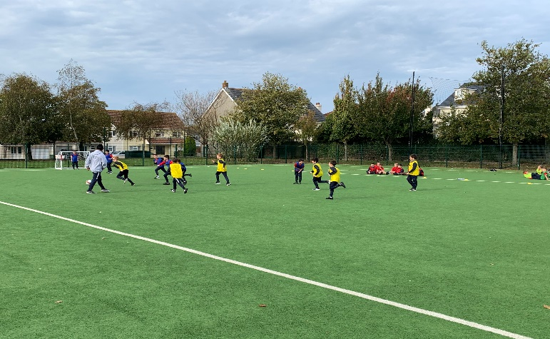
Haute Vallee
Many of our senior pupils took the opportunity this week to visit our partner school, Haute Vallee, during their Open Evenings. Feedback from the children and parents has been really positive and the children are so excited about their next steps in 2021 and beyond.

Finally…
So, our first full half-term in our new normal has come to an end. Time to take a breath and relax for a few days. I should like to publicly express my thanks to my colleagues for their efforts over the last few weeks. I expect a lot at times and they never fail to step up in whatever aspect of school life; I am very lucky to work with such a talented and committed group. Thank you, staff.

Stay safe everyone and thanks for your continued support.
Kindest regards,

Mr Cooper
Year Group Updates

Nursery
This week we have enjoyed exploring our new books which were kindly donated to us by Laura, thank you so much! A shelf full of new books has inspired lots of reading.
This week we would love to see your reading at home. Can you upload a picture of your favourite book? Or tell us a story?

Thank you to all the families who have been uploading home learning into Tapestry. We have loved sharing these with the children, they are a great talking point for developing the children’s listening and attention skills.

We can’t wait to see you again after half term, we hope you all have a fabulous week! Well done Nursery for doing such an amazing job during your first half term!
Thank you to all the Parents/Carers for your support so far,
Mrs Knight

Reception
What a wonderful week we have had in Reception.

Reception have shared the story 'Meesha Makes Friends' and talked about how to make friends by asking 'will you play with me?' or 'can I play with you?'

We continue our maths this week with the number 5, and once again any work you can do at home spotting, writing and counting forwards and backwards to and from 5 would be really beneficial.

We encourage the children to have a go at writing their name whenever and wherever possible. If your child is struggling with holding a pencil there are still many ways they can practice. Writing with their finger in sand or a tray of shaving foam or salt is lots of fun, as well as using paints or even just tracing over their name with their finger.

Our busy week ended with children wearing safety goggles and using hammers and nails to decorate pumpkins with things they found in the creative area.

Wishing you a lovely half term,
The Reception Team

Year 1
WOW what a start to Y1, we've had a fabulous half term learning all about The Enchanted Woodland and even had a visit from a real-life hedgehog to end our week!

Next half term we will be learning about different celebrations starting with Bonfire Night. On Thursday 5th November please ensure to send your child into school with a pair of named gloves as we will be learning how to stay safe with sparklers.

Each child has been given an email address to access Google Classroom. You may need to use this for your upcoming parent consultations if you have requested a video call. These will be stuck into the front of their home learning diaries.

Over half term, please could you practice tying shoelaces and zipping up coats with your child so they can do these tasks independently in school.

Finally, just a gentle reminder, Year 1 does not officially open until 8.20am, and we take the register promptly at 8.30 (unless they have an older sibling). If you need your child in earlier for whatever reason, breakfast club is provided from 7.30am.

We hope you have a lovely restful half term,

Miss Fage and Mrs Prothero

Year 2
What a busy half term we have had in Year 2. The children are now settled into their routine and are working towards becoming more independent.

On Monday, we had a visit from Helen Otterwell from Jersey Heritage to talk to us all about Neolithics and the Stone Age. All the children enjoyed looking at all the artefacts especially the polished axe and flint stone. Hopefully, you will get the opportunity to take your children to visit La Hougue Bie and view the Neolithic Long House.

Do you know which ingredient melts ice the quickest? Sugar, spice or salt? Speak to your little Scientists and they will be able to tell you all about our investigation this week. See if they can remember what happened and why.

A polite reminder; please only send your child to school with their d'Auvergne book bag and lunch bag. There are a few more big back-packs creeping into school and we do not have the space to accommodate them.

Over the half term holidays, please continue to read with your child, practise handwriting, spellings and keep going with Mathletics. We really do appreciate your support with home learning, but we also realise the children will be ready for a break.

Happy half term,

Mrs Lutkin-Clarke and Mrs Andre Brown

Year 3
This week the children have been working hard drafting and writing their Greek myth. They have produced some incredible work, and these will be going up on display.
In addition, 3B and 3d have been practising their art skills and have been drawing portraits of Rosie whilst she sits in front of them. The children really enjoyed this activity and we certainly have some amazing artists in the making! Some of the work will be going on our Facebook page so please have a look. 3GD will be doing this activity next half term.
We have combined some of the pictures from our wonderful Groovy Greek Day and will be sharing these with you all soon.
Miss Banks, Miss Dunn and Mr Du Feu

Year 4
What a fabulous week! The children have been working tirelessly on the finishing touches of different pieces of work to ensure they are ready for the Year 4 Beautiful Things Book. This is a celebration of all the wonderful learning this half term and will be displayed in the front of the school after half term for the rest of the year.
This week the children danced their final dance with Dragos. Hopefully, the children are all able to share the routines they learned with you at home. A big thank you to Jersey Sport for sharing Dragos with us.
The Body Buzz games are almost finished - just some electrics to deal with. We have been very impressed with the standard of finish of these games and will take lots of photos for the children to keep in their books so that they have some treasured memories to share with you.
In maths we have been working on 'regrouping and renaming' in addition. We have noticed that some of the children have forgotten their number bonds to ten and twenty. Please practice sharp and quick recall of these over half term.
Hit the button https://www.topmarks.co.uk/maths-games/hit-the-button is a good online game - click on the 'Make 10' or 'Make 20' games and see if your child can beat you!!
We do hope you all have a wonderful week and look forward to seeing all the children back at school, ready for our 'Invaders and Raiders' topic next,
Please, as always, do get in touch if you have any queries.
Mrs. Lawrence a.lawrence@dauvergne.sch.je
Miss. Shurey j.shurey@dauvergne.sch.je
Mrs. Wilkinson s.wilkinson@dauvergne.sch.je

Year 5
What a super half term we have had completing our stargazer topic!
This week, we have completed our Solar System orrery, these look great! We have created our Beautiful Thing Book with all our best work from our Stargazer topic, including our myth writing, planet mnemonics, space artwork and lots of our fabulous science work.
Achievers this week:
5KL – Sandra, for completing an amazing independent myth. Sandra has listened to advice carefully and included all the features we learnt about. Well done Sandra!
5H - Malo - for being my mini-teacher. You always find the time to support others with their learning as well as completing your own to the highest standard. You are also a maths whizz, especially with your times tables. Your speed would definitely give me a run for my money. Keep up the hard work!
5L - Nina - For being so incredibly switched on as soon as she walks through the school gates. She's an independent, self-motivated learner who is always up for task and thrives on all forms of learning. Go Nina my right-hand man!
5KL are looking for a parent helper for one swimming sessions next half term, if you can help out on Thursday 26th November at 8:40 till 10:00 please contact Miss Leighton k.leighton@dauvergne.sch.je. Thank you in advance.
We hope you have a restful break, ready to come back to start our new topic Frozen Kingdom.

Year 5 Team.

Year 6
This week the children have worked incredibly hard producing their adventure story narratives, based on our class text ‘The Secrets of Platform 13’.
The children have also produced moving avatars with Mr Livesey and we saw some FANTASTIC teamwork during the House Team football matches.
Over half term the child will be given a copy of our class text to enable them to finish the story and find out what happens in the end. Please can these be returned when we come back to school?
Comprehension questions will also be available for those who want to refine their reading skills on Google classroom.
Our achievers this week are:
In 6AW our achiever is Iza for her ‘Bend it like Beckham’ approach to House Football. Striking, in goal she played like a pro! Well done! In 6W, Ilya is our achiever this week for his fabulous problem-solving and critical thinking skills, which he demonstrated in Maker Space. He has also written an exciting adventure narrative, complete with outstanding illustrations.

