Dear Parents and Carers,
Head Teacher’s Comments
At last some sunshine today! How welcome was that! As the evenings lighten a bit, we are getting a number of children hanging around after school (wanting to go on the field / Pirate Ship etc). Whilst we would love to revert to being able to support this, we do need children and parents to leave the premises in a timely manner to avoid mixing. Please bear with us – this situation won’t last forever!

I have welcomed many children visiting my office this week, showing me their amazing learning. This is a reflection of their efforts and the great teaching they are receiving. Well done all! Whilst it’s obviously not easy for us to share this with you at the moment for you to see, please be assured that we are really knuckling down to the challenge of playing ‘catch-up.’ Our half-term data on every child is being collated today and will be analysed over the coming week. You will be informed of their latest progress and attainment during next half-term’s Parent Consultations, which teachers are currently arranging.

I have been speaking with colleagues at the Education Department today, as I do every Friday. They were pleased to inform me that all schools / colleges and nurseries haven’t recorded a single case of Covid-19 this week – this is the first time in months. This is a reflection of the strong efforts that we are all making in the fight against the virus, both at home and in school. However, now is not the time to be complacent. Together we have to keep d’Auvergne (and other schools) open. Mixing of households / sleepovers / play dates will have to wait until we are given the all-clear. The end is in sight – so let’s keep going everyone!

Take care.

Kind regards,
Mr Cooper.

Year Group Updates
Nursery
We have been showing an interest in the weather, talking about the colours of the clouds and what that means.

We have also started learning letter sounds. This week we looked at 'e', 'l', 'h', 'sh', and 'r'. Please look at these together at home. Click on the links below to look at pronunciation and to learn the handwriting phrases to go with each letter, saying these aloud when writing helps children to learn the correct letter formation which is really important.

https://www.youtube.com/watch?v=qTvT3PWhPR8&list=PLVB0Ddgu7ewF2JC3SFa1I_El66qOMxeTl&index=18
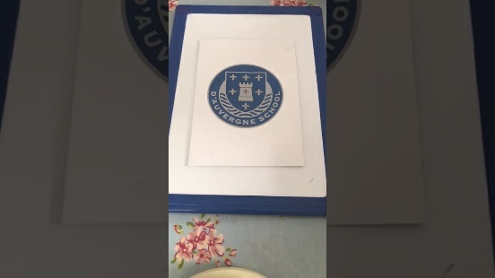 | RWI- Speed Sounds - Set 1 “e”  www.youtube.com

https://www.youtube.com/watch?v=h0aPM1yNMTQ&list=PLVB0Ddgu7ewF2JC3SFa1I_El66qOMxeTl&index=17
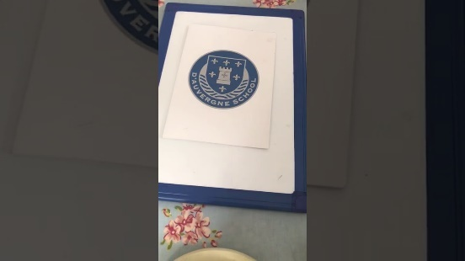 | RWI - Speed Sounds - Set 1 “l”  www.youtube.com

https://www.youtube.com/watch?v=drGRkXrkOoo&list=PLVB0Ddgu7ewF2JC3SFa1I_El66qOMxeTl&index=16
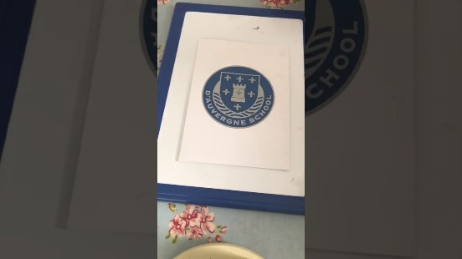 | RWI - Speed Sounds - Set 1 - “h”  www.youtube.com

https://www.youtube.com/watch?v=2xDeN2CkG6w

Read Write Inc. - sh
www.youtube.com
https://www.youtube.com/watch?v=TF3FZFNKJl8
Read Write Inc. Phonics 'r' sound (complete lesson)
www.youtube.com

In Maths we have been learning all about the number 4. What it looks like, how to write it, finding it around the room, counting one object, counting a clap/jump/hop and talking about one more and one less than 4. Next week we will be looking at number 5.

Have a great weekend,

Mrs Knight

Reception
Another busy week in Reception. This week we have been learning and writing about similarities and differences between ourselves and reading all about the fabulous Frida Kahlo.
If your child is doing any home learning that you can capture a photograph or video of, we would love to see this on either Tapestry or email. The children love to show their friends what they have been learning about at home and opens lots of conversation about ‘having a go’.

Please can you keep encouraging your child to practice their number ordering and recognition at home as this will make a big difference to their progress at school!

Thank you and have a lovely weekend,

The reception team!

Year 1
This week, Miss Fage and Mrs Prothero attended a webinar on Mathletics. This is an amazing maths resource that we provide for your children in Y1-6, however sadly some children are still not accessing this online learning enough. Please ensure that your child is doing lots of Mathletics each week at home - they could even earn a certificate for doing so!
It has been lovely on a Friday to see the children's handwriting that they have been doing at home.
Each week we will be putting in a new sheet of patterns and letters to practice in their red handwriting books. Please remember to keep the handwriting folders in your child's book bag so that we are able to do this.
Just a gentle reminder that book bags are not to be used for water bottles, clothes, wellies... we often need to access them in the day so that we can listen to your child read so it is important that its only books in there for the ease of your child.

Please keep up all the fabulous work you are doing because we are seeing great progress!

Miss Fage and Mrs Prothero

Year 2
This week Year 2 have started learning about division and the children soon noticed the connection with multiplication. Please keep practising quick fire timetables at home and accessing Mathletics, it's a great platform for consolidating their learning from school.
We have been writing our acrostic poems, it has been wonderful to see the children including thier knowledge about The Great Fire of London; a huge thank you to those of you who have researched information at home too.
Next week, we are doing something very exciting with 'Stop Motion'; we will be creating an animation of The Great Fire of London. If your child would like to bring in a mini character from Lego or playmobil to use in their animation, they may do so on Monday. Please remind them, it is their responsibility to look them and they must keep them safe.
I'm sure you've heard about d'Auvergne's Got Talent..well, Year 2 are holding their class auditions on Tuesday 9th February so if your child would like to enter, they must bring in any music, instrument or resources they will need on Tuesday and, if they get through to the final, they will need them on Thursday too. Several of them have already been practising their moves out on the playing field at breaktimes!
A quick reminder about uniform, now that the shops are open, please make sure your child is dressed in full d'Auvergne School uniform from head to toe! PE remains on Mondays and Thursdays.

Thank you for your continued support, have a lovely weekend.

Mrs Lutkin-Clarke and Mrs Andre Brown
Year 3
This week the children have begun looking at different units of measure, focusing on length using mm, cm and m’s. Please encourage your children at home to investigate different lengths, thinking about appropriate units of measure, for example using metres to measure the length of a room and cm’s to measure a pencil.
In addition, the children have begun reading poetry, looking at the different forms and have begun to perform poems.
Over the next few weeks, we will be contacting you to arrange Parent Consultations. These will take place after half term.
We hope you and your family have a lovely weekend.
Kind regards,
Miss Banks, Miss Dunn and Mr du Feu
g.dunn@dauvergne.sch.je l.banks@dauvergne.sch.je l.dufeu@dauvergne.sch.je

Year 4
Congratulations to 4L for winning the TTRockstars tournament across the year group last week. Who will win the Lower Key Stage Two tournament starting Friday? Come on Year 4 - keep it up...every point counts!

This week there have been some fabulous Native American Myths and Legends have been planned, discussed and written. Each and every one is a unique story about natural phenomenon or living things on our planet. Chief Seattle's speech has obviously inspired the children and we have been stunned with some of their creative thinking. Next week, we cannot wait for the children to share their stories around a class campfire. The children will get to sample some Navajo Fry bread too. We cannot make these at school because it can get rather smokey frying them (and Mrs. Lawrence set off the fire alarm last year!). All that is needed is vegetable oil, plain flour, baking powder and a little milk. If you would like to have a go at home, then here is a website with the recipe and instructions:

https://www.thespruceeats.com/native-american-fry-bread-4045432

Next week will be the children's last week of swimming. They have all made tremendous progress and it has been a joy to watch their confidence in the pool increase so much. After half term, the children will return to their usual PE sessions. We will inform you next week of the new PE days.

Have a lovely weekend - see if you can get your child to recall their Native American Legend to you,
Best wishes,
Mrs. Lawrence - a.lawrence@dauvergne.sch.je
Miss. Shurey - j.shurey@dauvergne.sch.je
Mrs. Wilkinson - s.wilkinson@dauvergne.sch.je

Year 5
A great week in Year 5! We have continued our French lessons, we are all so impressed with the progress every child is making.
We are starting to finish up on our topic of division and be moving into interpretating graphs.
In writing, we are preparing to write our big write, we will be trying to persuade our readers either to join the army or not to join the army.
Next week we have d'Auvergne's Got Talent! Our auditions will be held on Tuesday 9th, if you are auditioning please make sure you bring everything you need on this day. If you cannot perform your talent in the classroom, please ensure a video has been sent to your class teacher by Tuesday. We are so excited to see all your amazing talents!

Achievers this week:

5KL - Archie for putting more effort into his learning. He is focussing more in class and this is paying off. Well done Archie, let's keep this up!

5L - Lily T for showing a genuine interest in our topic this term of World War 2! A modern-day historian who would have done well on plotting the downfall of Hitler!

5H - Ethan C for his tremendous attitude to learning. Ethan is becoming more independent and taking charge of his own learning. He is really developing a curiosity to find out more, but also smashing Mathletics! I am sure Mathletics will have a statue dedicated to you soon! Very proud teacher!

Year 6
This week we had an AMAZING session in the maker space with Mr Livesey where we showed us the wonders of zoetropes, super inventions created by William George Horner in 1834. We had a go at piecing our own versions together and will conclude this work next week.
We have looked at life aboard the HMS Beagle and continued to read Sky Hawk. Our Maths chapter on Fractions has reached its conclusion and now we are excited to begin learning about Decimals!
This week’s super star from 6W is Amy for her amazing progress in reading. I used to have to nag her to read, but now I have to ask to put her book down! She also asks for another book, before she has finished the book she is on, so that she has something to read next. This has made me super happy and is fantastic to see.

In 6AW, Mrs Wheaton was impressed by Ollie’s dedication and time spent creating a wonderfully detailed sketch of the HMS Beagle. Well done Ollie, your ship is incredibly impressive.
Next week we will celebrate Darwin Day on Friday 12th February, if you would like to come to school dressed as Charles Darwin or an animal from the Galapagos please feel free. During the day we will be conducting investigations into ‘Which beak is best?’, creating some fabulous animal based poetry and art work before concluding the day by trying some bugs… yes bugs! Just like Charles Darwin did while on the Galapagos 😊
Don’t forget…. Our House competition this term is ‘d’Auvergne’s got talent’ we will have the auditions on Tuesday lunch in class before the semi final/final in the hall on Thursday! If you would like to enter by video should your talent not be able to be completed successfully in school please do send these in to Mrs Wheaton or Mrs Watston.
a.wheaton@dauvergne.sch.je n.watson@dauvergne.sch.je

