Dear Parents and Carers,
Head Teacher’s Comments
My congratulations and thanks to all the magnificent participants in this week’s “d’Auvergne’s Got Talent!” It was a pleasure to be on the judging panel alongside Veronica and Taylor. Between us we decided Caitlin (Y6) was our 2021 winner, with Harry and Lea tied for second place. Well done all and thank you to Mr Henderson for all your organisational efforts.

This morning, we had another visit from the BBC. Vasco, Tosia, Alex and Veronica (all Y6) were simply outstanding ambassadors for our school. The reporter commented that she thought their answers to her questions were better than any she had experienced from school children. Please tune in to BBC Channel Islands News on Monday at 6.30pm or throughout Monday on Radio Jersey to see / hear their contributions. Well done children!

As the half-term draws to a close, I attach a letter from our Deputy Medical Officer for Health, Dr Ivan Muscat. It gives parents / children an update on the current health advice and I strongly encourage you to read it and act on the guidance. Thank you.

To all those children who are being tutored this half-term holiday, please make sure that you attend every session offered and that you turn up on time! This is a great opportunity for those involved and I thank my colleagues and the children for their commitment to it.

Finally, PLEASE make sure that your child does lots of reading this break. It really is the key to success in school. Do ask them questions about what they have read to you. Ask them to explain why particular punctuation is used. Get them to think of alternative words for the ones in the text that mean the same. Have them describe how a character might be feeling….explain why….where’s the evidence for that?
If you want your child to be leaving d’Auvergne at the expected level in Year 6, regular reading is critical to achieving this.

Take care everyone,
Mr Cooper.

French Update
Mrs Kruk has prepared games to enable pupils to practice at home French taught in lessons. The links to the games have just been uploaded onto the French section of d'Auvergne website.
In the French section in part 7. 'Mrs Kruk's games' are 11 links to over 40 different games to revise vocabulary and some sentence structures. Enjoy playing games with your children and help them to reinforce the language.
Below is a link to our French section on the school website:

French - d'Auvergne School
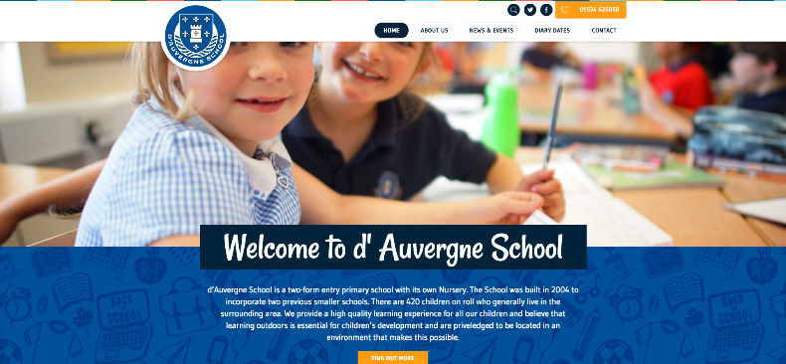 | French - d'Auvergne School  1. French – English dictionary: https://www.linguee.com/english-french . 2. Songs in French: la chanson des voyelles (Learn French) Bonjour, Bonjour! - alain le ...  www.dauvergne.sch.je

Maths Updates from Mrs Wheaton
TTRockstars:
Congratulations to 4L and 5H who won their respective Key Stage Tournaments last weekend. Over the half term we will have a whole Key Stage 2 tournament beginning on Friday 12th at 3pm and concluding Sunday 21st at 6pm. This will produce the TTRockstar Tournament overall Champions and the best 10 TTRockstars from the whole of KS2.

TTROCKStars Participation:

Year Group | Participation last week | Participation this week
3 | 69% | 54% -15%
4 | 40% | 33% -7%
5 | 77% | 68% -9%
6 | 89% | 93% +4%
Top stuff Year 6, you are setting the standard here!

Mathletics Participation:
Another sterling effort from Year 5 and 6.
Year Group | Participation last week | Participation this week
1 | 71% | 59% -12%
2 | 83% | 86% +3%
3 | 84% | 66% -18%
4 | 77% | 74% -3%
5 | 56% | 70% +14%
6 | 50% | 75% +25%

Year Group Updates
Nursery
We have been showing an interest in the weather, talking about the colours of the clouds and what that means.

We have also started learning letter sounds. This week we looked at 'j', 'v', 'y', 'w', and 'th'. Please look at these together at home. Click on the links below to look at pronunciation and to learn the handwriting phrases to go with each letter, saying these aloud when writing helps children to learn the correct letter formation which is really important.

https://www.youtube.com/watch?v=Qe2eGnWEj9g

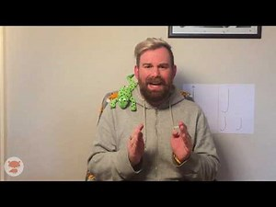 | Read Write Inc. - j  Read Write Inc. - j  www.youtube.com

https://www.youtube.com/watch?v=Zsp2O_wTtNE
Read Write Inc. Phonics 'v' sound (complete lesson)
www.youtube.com

https://www.youtube.com/watch?v=7j0FQDs7G1g&list=PLVB0Ddgu7ewGCwrhUvCphCyx3eUTgJO8c&index=17
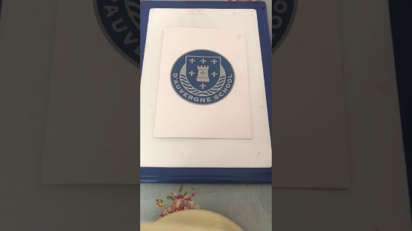 | RWI - Speed Sounds - Set 1 “y”  www.youtube.com

https://www.youtube.com/watch?v=9Iyj2UTmUtY&list=PLVB0Ddgu7ewGCwrhUvCphCyx3eUTgJO8c&index=18
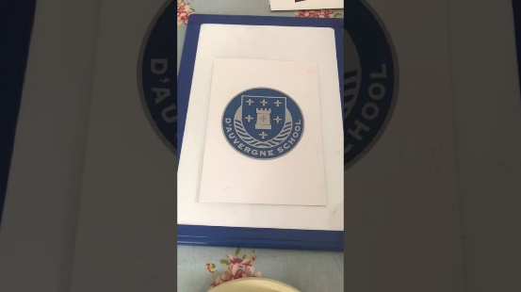 | RWI - Speed Sounds - Set 1 “w”  www.youtube.com

https://www.youtube.com/watch?v=-1HzrT6WePI&list=PLVB0Ddgu7ewGCwrhUvCphCyx3eUTgJO8c&index=19
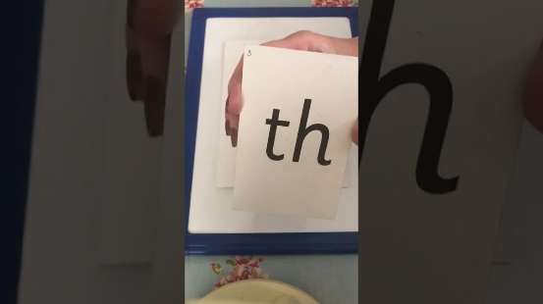 | RWI - Speed Sounds - Set 1 “th”  www.youtube.com

In Maths we have been learning all about the number 5. What it looks like, how to write it, finding it around the room, counting one object, counting a clap/jump/hop and talking about one more and one less than 5.

Please practise all of the numbers from 0-5 over half term so that the children come back ready to move onto the next stage.

Have a wonderful half term!

Mrs Knight

Reception
What a busy final week before our holidays! Reception have been enjoying playing in the snow and the cold weather has not stopped us from learning outdoors! We have experimented with painting and moulding snow, frozen ice puddles and exploring patterns and change in the environment. We have had great fun developing our understanding of the world and language skills.
In Maths, we have been learning all about comparing quantities and have introduced key vocabulary such as more, fewer and equal to. There are many simple activities that you can do in your home to embed this language and concept with your child. For example, food shopping or folding laundry etc. Questions you could ask are:
- Which one has more?
- Which one has fewer?
- Are any the same or equal?

On Friday, we will be sending home some holiday learning sheets. These are fun activities that will help your child with developing their literacy and numeracy skills.
Most importantly, we are so proud of all the Reception children this term. They have worked so hard and deserve such a 'big well done' for their efforts with their learning. Have a lovely half term and we shall see you all soon!

Take care,
The Reception Team

Year 1
WOW - what a term! We hope that your children have loved our 'Paws, Claws and Whiskers topic' as much as we have. We've learnt about ourselves and our own bodies, pets, and jungle animals. This week we have been looking at which continents some of the animals have come from, learning how to name and locate the 7 continents in the process. The children have all really loved the song that has helped us to do this, please enjoy singing along at home helping to reinforce this learning!
https://www.youtube.com/watch?v=K6DSMZ8b3LE
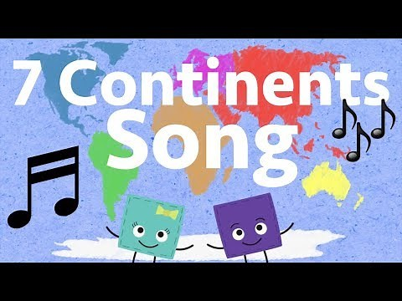 | Seven Continents Song  A song to help kids learn the 7 continents in order from largest to smallest. Subscribe! https://www.youtube.com/c/hopscotchsongs?sub_confirmation=1 Visit the Hopscotch Shop! https://www.hopscotchsongs.com/shop Download the song https://www.hopscotchsongs.com/shop/seven-continents-mp3 Listen on: Spotify https://open.spotify.com/album ...  www.youtube.com

Next half term we are very excited to learn all about pirates. On Monday 8th March, we hope to have a 'pirate day' where your child can come to school dressed as a pirate.
You will have received some pirate topic words this week. Please check your child's bookbag for these and read the words with them over half term, checking that they understand them.

Enjoy half term, please don't forget to read read read read read read (and read some more!!)

Miss Fage and Mrs Prothero

Year 2
This week we have been creating our Stop Motion animations of The Great Fire of London, it was tricky to remember to hold the iPad camera still and only make tiny movements with the characters. We've had lots of fun and learnt a new skill so hopefully we'll have another go next half term with our 'Wiggle and Crawl' topic.

We have also been learning about how to be safe on the internet and we created posters to tell all our friends about what we know. Ask your children if they can tell you the top tips on keeping safe. Perhaps you'd like to watch this short film with them about internet safety; it's a good reminder to all of us to be mindful of teaching our children to be safe when using devices: https://www.youtube.com/watch?v=-nMUbHuffO8

Half Term Challenge
Over the half term holidays, we have a challenge for all the children...to learn to tie their own shoelaces. Please help them to be more independent with this.

PE days remain on Mondays and Thursdays after half term.

Next half term we will be go. go. go as we complete our second half of Year 2...we still have lots of learning to do!
Thank you for all your continued support this half term, please keep reading with your children, help them learn their times tables but most of all enjoy some family time together.

Mrs Lutkin-Clarke and Mrs Andre Brown

Year 3
This week the children have continued being measuring mathematicians and are getting on really well with this highly practical topic.
In addition, they have written their very own poem inspired by the poem ‘Last night I saw the city breathing,’ by Andrew Fusek-Peters.
They have also met Farmer Phil over Teams who is a local farmer who is based at Master Farms and we all enjoyed meeting him and his wonderful cows.
If you have not already booked in a telephone consultation with your child’s class teacher, please contact them by the end of this week.
We hope you and your family have a lovely half term.
Kind regards,
Miss Banks, Miss Dunn and Mr du Feu
g.dunn@dauvergne.sch.je l.banks@dauvergne.sch.je l.dufeu@dauvergne.sch.je

Year 4
The Year 4 super swimmers have had their final swimming sessions this week and we have been so impressed with the example they have set for d'Auvergne whilst being off site. We would like to say well done to all the children for being organised and ready for these days. More importantly, we wish to say a huge thank you to Haute Vallee for the use of the pool and to Martine. Both she and her team of coaches have been extremely understanding and really motivated your children to feel more confident in the water. We would also like to thank all the adults who have given up warm, cosy mornings to walk with us, back and forth to Haut Vallee, regardless of wind, rain, shine, snow and ice!

During the half term week, please take a moment with your child, to sit with them and focus on their handwriting. We are very aware that we live in an increasingly technological world, but the formation of letters and presentation of handwritten work still remains extremely important. The children have all got handwriting books with additional lines in them. The main body of each letter should be formed inside the two grey lines, with the 'necks' of tall letters and 'tails' of long letters going outside these grey lines only. Please watch to see if your child is forming the letters in a consistent size (using these lines) and then joining them according to the guidance on the sheets provided.

After half term, our topic is called 'Playlist'. We are looking forward to a musically creative half term with some song writing and performing going on. Share your favourite tunes with the children and (if appropriate) we will share some of them in class. Also, please start to collect plastic cartons and boxes that the children could use to make their own musical instruments with.

After half term, our PE days are Wednesday and Thursday. We will be outside so please make sure the children are appropriately dressed.

We hope you all have a wonderful week,
Best wishes,
Mrs. Lawrence - a.lawrence@dauvergne.sch.je
Miss. Shurey - j.shurey@dauvergne.sch.je
Mrs. Wilkinson - s.wilkinson@dauvergne.sch.je

Year 5
What a fantastic last week! We have been so busy, finishing our persuasive writing, finishing our French experience, and finishing our maths chapter on graphs.

We are looking forward to continuing our learning on World War 2 after half term, we will be looking closer into The Occupation in Jersey. After half term we will be starting our new maths chapter on fractions.

Our achievers this week:

5KL: Jason for working hard on his handwriting, it is very clear he is working hard to ensure he is making progress. Jason's handwriting has visible changed and looks great! Well done Jason.

5L: Lilly S! For being such a hardworking, high achieving student. She has a strong desire for success and could have easily won this award weekly, such is her quality. Well done you legend and scholar!

5H: Cameron, for his tremendous efforts with home reading! Cameron is starting to really progress his reading by ensuring his evenings are now fully ‘booked’. Well done Cam! Super proud teacher!

Please remember to keep up your super home learning over the half term, make sure you continue reading, accessing Mathletics and TTRockstars and catching up on your handwriting, which can be found on our Google Classroom pages.

Have a great half term!

Year 5 team

Year 6
What a brilliant and successful week we have had in Year 6!
We have continued to read ‘Sky Hawk’ and the children have copies to take home to conclude over the half term period.
The children have produced some beautiful Explanation Texts, explaining the evolution and adaptation of the fictional ‘Three Eyed Galapagos Toad’.
We LOVED Darwin day and have created some beautiful Art and Poetry as well as exploring ‘Which Beak Is Best?’ using spoons, chop sticks, forks and tooth picks as beaks and picking up a range of ‘seeds’. Some of us were even brave enough to try some grubs!!

6W's achiever this week is Emily, for being a shining star in our class. She strives to be the best person that she can be on a daily basis, by displaying the d'Auvergne standard in all that she does. She gives 110% in every subject - not only in class, but also in her homework. Her explanation text as to why the Galapagos toad has three eyes was expertly written! Thank you, Emily, for all your hard work and for being such a kind and supportive peer to everyone in 6W. While in 6AW, our achiever is Honey! She has recently ‘logged on’ and has collected enough points in Mathletics to earn a couple of bronze awards. Well done Honey, this will really help your maths! Keep it up!

After half term, we will begin our new topic ‘ Blood Heart ‘ and our new text ‘Pig Heart Boy’, we have an incredible learning journey ahead with lots of fantastic opportunities to gain new knowledge. Over the holidays please continue to read as much as possible, regularly log on to Mathletics and TTRockstars (don’t forget there is a whole Key Stage 2 Tournament beginning on Friday at 3pm and running until the Sunday before we come back to school).

