

Headteacher: Mr Sam Cooper
Deputy headteacher : Mrs Alex Wheaton
SENDCO : Sally Lacy-Kerr

Dear parents and carers,
The aim of this policy is to explain how we implement our SEND policy in line with Special Educational Needs Code of Practice for Jersey, 2017 and the Government of Jersey’s Special Educational needs Policy - SPECIAL EDUCATIONAL NEEDS POLICY
Note: If there are any terms we’ve used in this information report that you’re unsure of, you can look them up in the Glossary at the end of this report.

Policy Statement
At D’Auvergne Primary School, we are committed to providing an inclusive environment where all pupils, including those with Special Educational Needs (SEN), are supported to achieve their full potential. We recognise that every child is unique and aim to remove barriers to learning through high-quality teaching, strong relationships, and personalised support.
A fundamental understanding underpinning our approach is that well-being and positive relationships are the cornerstones of successful learning. Children feel safe, valued, and confident in knowing who they can talk to when they have concerns.
Aims and Key Practices
We aim to:
- Work collaboratively with children and their parents to develop personalised plans that meet individual needs and build essential life skills, including self-advocacy
- Hold regular and timely review meetings to evaluate progress and next steps
- Ensure class teams work collaboratively to support SEN learners and regularly share feedback and strategies
- Maintain a rigorous whole-school cycle of monitoring, assessment, and evaluation to identify pupils at risk of falling behind
- Closely monitor the profile of SEN across the school, deploying staffing and resources responsively to meet cohort needs
- Promote early identification and targeted intervention, reducing long-term barriers to learning and risks to mental health
- Deliver responsive, adaptive teaching, aligned with Ordinarily Available Provision expectations
- Provide personalised curricula for pupils working outside age-related expectations, built around strengths and tailored outcomes
- Work proactively with external agencies, ensuring families receive holistic support (including opportunities such as coffee mornings)
- Ensure staff training compliments the school development priorities and the evolving needs of pupils
Definition of Special Educational Needs
A pupil has SEN where their learning difficulty calls for special educational provision, namely provision different from or additional to that ordinarily available to pupils of the same age.
At d’Auvergne, we identify special educational needs by building on information from previous settings, discussions with parents/carers and the pupil, consulting with other agencies, the class teacher, assessments (both teacher and SEN specific) and information from previous teachers.
Our first response is high quality teaching, targeted at a pupil’s area of need. Where progress continues to be slower, teachers work with the SENCO, to assess whether the child/young person has SEN and which category of need it can be identified as – communication and interaction, cognition and learning, social, emotional and mental health difficulties or sensory and/or physical needs.
The purpose of identification is to aid us in planning how to best meet a child’s needs and if necessary which agency to consult for support.
At d’Auvergne our identification process allows us to ensure other factors that may impact progress and attainment are not wrongly identified as SEN, including but not limited to; attendance, having English as an additional language or health and welfare
A pupil has SEN if they have a learning difficulty or disability requiring provision additional to or different from their peers.

Identification of a Special Educational Need
At d’Auvergne, we identify special educational needs by building on information from previous settings, discussions with parents/carers and the pupil, consulting with other agencies, the class teacher, assessments (both teacher and SEN specific) and information from previous teachers.
In accordance with the SEN Code of Practise , a special educational need is identified within the categories below.
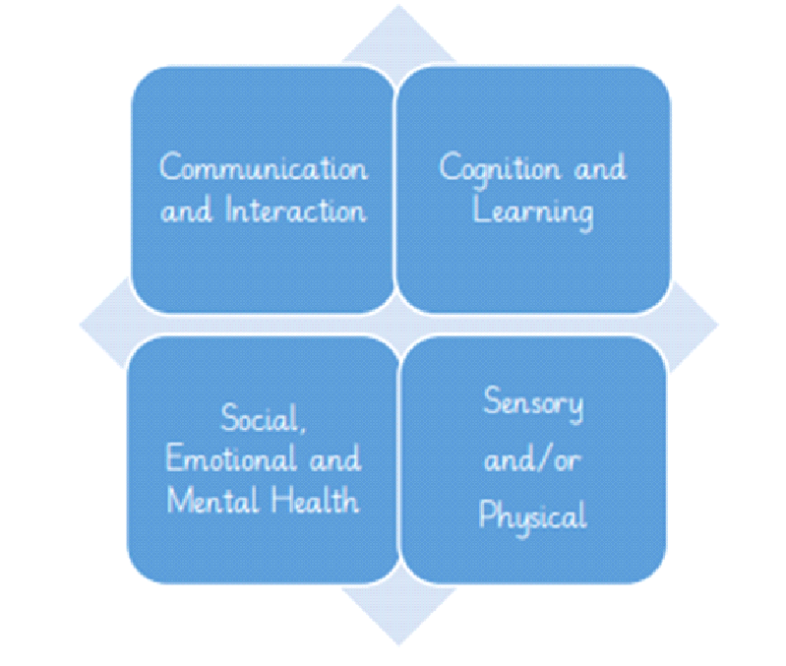
We value the opportunity to work closely with parents whose views and aspirations for their child will be central to the assessment and provision that is provided by the school.
The process if identifying a child’s needs is summarised below:
In the first instance | Next step | Outcome
If you think your child might have SEN, the first person you should tell is your child’s teacher. Arrange to meet with the teacher to discuss your concern.  The teacher will share your concerns with the SENDCO and consider the best support and advice regarding possible next steps.  The teacher may monitor your child’s progress and feedback at the end of an agreed period.  Or  The teacher may have identified an area where they feel your child needs additional support and they will raise the concern with the SENDCO  You can also contact the SENCO directly. | We will meet with you to discuss your concerns and try to get a better understanding of your child’s strengths and barriers are.  Together we will decide what outcomes to seek for your child and agree on next steps.  We will make a note of what’s been discussed and add this to your child’s record. | Following the previous actions , if your child’s needs are not able to be supported as part of the Ordinarily Available classroom offer (in line with the Jersey Inclusive Practice Guidance) we will create a School Support Plan and share this during a meeting with you, and your child will be added to the school’s SEND register.

The SENCO will meet with your child’s teacher, to see if there have been any issues with, or changes in, their progress, attainment or behaviour. They will also compare your child's progress and development with their peers and available national data.
The SENCO will ask for your opinion and speak to your child to get their input as well. They may also, where appropriate, ask for the opinion of external experts such as a speech and language therapist, an educational psychologist, or a pediatrician.
Based on all of this information, the SENCO will decide whether your child needs SEN support. You will be offered regular meetings throughout this process.
If your child does need SEN support, their name will be added to the school’s SEN register, and the SENCO will work with you to create a SEN support plan for them.

d’Auvergne’s Graduated Approach to SEN
All pupils are provided with high quality teaching that is adjusted to meet the needs of all learners. The quality of classroom teaching provided to pupils with SEND is monitored through a number of processes that include:
Monitoring of teaching and learning by the school’s Leadership Team, the SENDCO and external agencies.
Ongoing assessment of progress made by pupils with SEND.
Work sampling to ensure effective matching of work to pupil need.
Teacher meetings with the SENDCO to provide advice and guidance on meeting the needs of pupils with SEND.
Support staff meet with the SENDCO discussing any observations during interventions and general classroom support.
Pupil and parent feedback on the quality and effectiveness of interventions provided
Attendance and behaviour records.
We will follow the ‘graduated approach’ to meeting your child’s SEN needs. The graduated approach is a 4-part cycle of assess, plan, do, review.

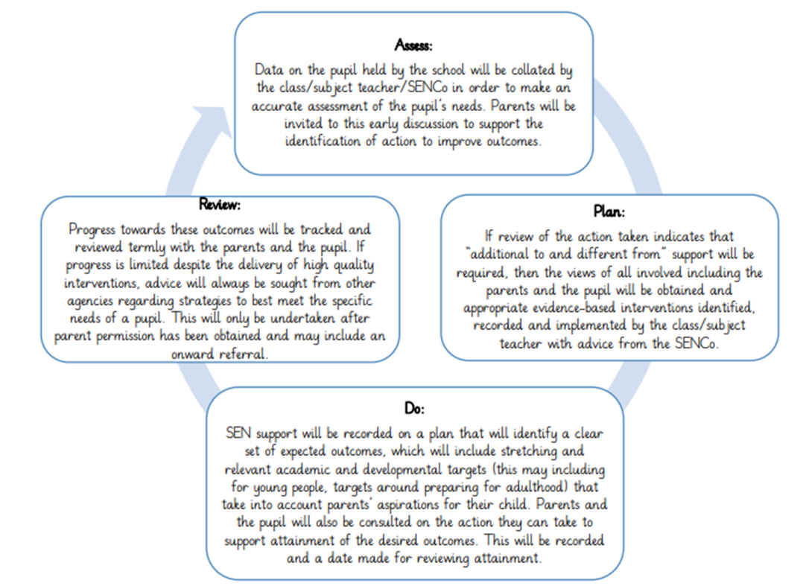
Monitoring of the SEND School Support Plan

You will be invited to a termly progress review to discuss your child’s progress. Where you will meet with the class teacher and, where appropriate, the SENDCO to:
- Set clear outcomes for your child’s progress
- Review progress towards those outcomes
- Discuss the support we will put in place to help your child make that progress
- Identify what we will do, how you can support at home, and what we will ask your child to do
Once we have shared the review and the updated plan, we will make a record of any outcomes, actions and support that have been agreed. This Support Plan will be stored on the Edukey Provision Mapping platform and a paper copy will be shared with you. If your child has a Record of Need you will be given a unique passcode where you can access all of your child’s School Support Plans.
If you have concerns that arise between these meetings, please do contact your child’s class teacher or the SENDCO via D'Auvergne Inclusion email: inclusion@d’Auvergneprimary.co.uk.

Training and Resources

All staff receive regular, relevant and up to date training. Training needs are informed through observations, audits, need of pupils and through discussions with staff. We regularly hold in school training led by staff, outside agencies, or professionals from the UK. Staff also attend training held by the Education Department and when necessary we will attend training opportunities in the UK.

Roles and Responsibilities

In line with the Jersey 2019 SEN Code of Practice, we believe meeting the needs of pupils with SEN is everyone’s responsibility. We have a shared vision of inclusion and understand how we all contribute to pupils learning and progress.

The school’s SENCO is responsible for the day-to-day implementation of The SEN Policy and co-ordination of specific provision made to support individual pupils with SEN.

The SENCO provides professional guidance to colleagues and will work closely with staff, parents/carers and other agencies. The SENCO and Head Teacher will identify areas for development in special educational needs and these will contribute to the school’s development plan.

Storing and Managing Information

All information on pupils with SEN is stored in a named SEN file, in a locked filing cabinet. We encourage all staff working with the child to access this information. Any information sent via email will be password protected or a child’s initials will be used. We will always seek a parent’s permission before sharing a child’s information with any support agencies.

Accessibility

At d’Auvergne all teachers set high expectations for every child, whatever their prior attainment. We aim to identify and address potential areas of need at the outset. Lessons are planned to address need and to remove barriers to pupil achievement, such planning means that pupils with SEN and disabilities will be able to study the full Jersey Curriculum.

d’Auvergne aims to ensure that: -
- All efforts are made to overcome individual pupils’ barriers to learning
- All classrooms have well planned activities which are differentiated to enable all pupils to make progress
- Classroom resources are organised in such a way as to enable pupils to develop independence in selecting appropriate materials for a task
- A range of teaching styles are used including auditory, visual and kinaesthetic
- The successes and achievements of all pupils are celebrated through the school’s reward system
- All pupils are encouraged and enabled to have full participation in the life of the school and to know their contributions are valued
- A range of different organisational settings are planned to provide class, group, paired and individual work
- Progress is measured from a child’s starting point and not in relation to their peers

We have disabled toilets throughout the school. We have wheelchair access to the ground floor of the building and lift access to the second floor. The staircases have handrails and clear markings on the stairs. Some classrooms have a Soundfield system installed. We have an adjustable changing bed in one of our disabled toilets.

Supporting Pupils with SEN who are currently Looked After or Previously Looked After

Mrs Wheaton (Deputy Headteacher) will work with Mrs Lacy-Kerr (SENCO), to make sure that all teachers understand how a looked-after or previously looked-after pupil’s experiences and their SEN might interact, and what the implications are for teaching and learning.
Children who are looked-after or previously looked-after will be supported much in the same way as any other child who has SEND. However, looked-after pupils will also have a personal education plan (PEP). We will make sure that the PEP and any SEN support plans or RON plans are consistent and complement one another.

Supporting Pupils and Families

If you require further information about d’Auvergne School or wish to view our SEN Information Report you can visit our school website:
http://www.dauvergne.sch.je

For more information about assessing your child’s educational needs, delaying a school year or advancement, specialist schools and settings and support for children with special educational needs, please visit:
Special educational needs
Where you will find a host of information for parents, including, ‘The Parent’s Guide to the SEN Code of Practice’ and explanations of different SEN processes. This information is also available in Polish, Portuguese, and Romanian

Further Information and support (click the link)
Support for children and families Neurodevelopmental Support Pack
Young People, Education and Skills (CYPES) services- Jersey SEND Local Offer and Children,

Comments, Complaints and Questions
If you have any questions, comments or complaints please contact our School SENCO, Mrs Sally Lacy- Kerr s.lacykerr@dauvergne.sch.je or our Headteacher, Mr Sam Cooper s.cooper@dauvergne.sch.je
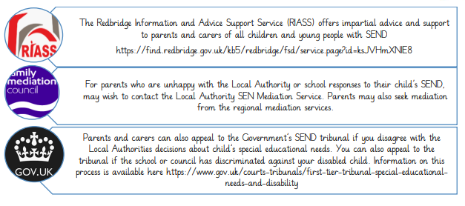
Glossary
- Access arrangements – special arrangements to allow pupils with SEND to access assessments or exams
- Annual review – an annual meeting to review the provision in a pupil’s RON plan
- Area of need – the 4 areas of need describe different types of needs a pupil with SEND can have. The 4 areas are communication and interaction; cognition and learning; physical and/or sensory; and social, emotional and mental health needs.
- CAMHS – child and adolescent mental health services
- Adjustments – when teachers adapt how they teach in response to a pupil’s needs
- RoN- Record of Need, In Jersey, an official, comprehensive document for children and young people with complex Special Educational Needs and Disabilities (SEND). It identifies the specialist educational arrangements and multi-agency support needed to help the child learn and prepare for adulthood.
- Exceptional Action Request – the needs assessment is the first step on the way to securing an RON plan. The local authority will do an assessment to decide whether a child needs an RON plan.
- RON plan – an education, health and care plan is a legally-binding document that sets out a child’s needs and the provision that will be put in place to meet their needs.
- Graduated approach – an approach to providing SEN support in which the school provides support in successive cycles of assessing the pupil’s needs, planning the provision, implementing the plan, and reviewing the impact of the action on the pupil
- Intervention – a short-term, targeted approach to teaching a pupil with a specific outcome in mind
- Local offer – information provided by the local authority which explains what services and support are on offer for pupils with SEN in the local area
- Outcome – target identified for improvement for pupils with SEND. These targets don't necessarily have to be related to academic attainment
- Reasonable adjustments – changes that the school are able to make to remove or reduce any disadvantages caused by a child’s Special Educational Need or disability
- SENCO – the special educational needs coordinator
- SEN – special educational need
- SEND – special educational needs and disabilities
- SEND Code of Practice – the statutory guidance that schools must follow to support children with SEND
- SEN information report – a report that schools must publish on their website, that explains how the school supports pupils with SEN
- SEN support – special educational provision which meets the needs of pupils with SEN
- Transition – when a pupil moves between years, phases, schools or institutions or life stages

